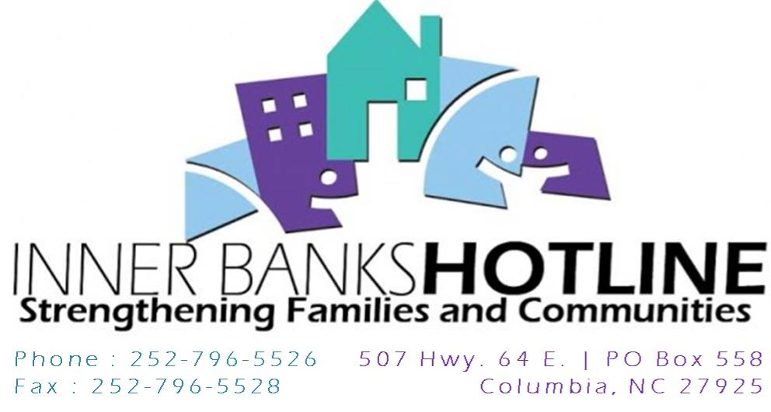  Presents:  “Serving Latinos Training”  March 31, 2017  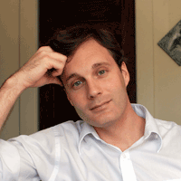  Speaker: Rev. David Fraccaro  Rev. Fraccaro is the Executive Director of Faith Action International House located in Greensboro NC. Prior to coming to Greensboro, David worked as an immigration specialist with the Interfaith Youth Core in Chicago, educating students and faith communities throughout the United States on immigration issues. Rev. Fraccaro is an ordained minister in the United Church of Christ, and has been a human rights volunteer for the UCC in Bolivia, Kenya, and East Timar, and with the United Nations.  - Training will be held at the Public Library from 10am to 3:00pm.  - Training is open to the community. | Training offers interested agencies crucial cultural competency training.  ────  Best practices for service, education, and outreach to our newest Latino neighbors on issues related to domestic violence and social service.  ────  COME OUT TO THE SERVING LATINOS TRAINING TO LEARN HOW TO BETTER SERVE OUR LATINO COMMUNITY!  ────  LUNCH WILL BE SERVED!  Inner Banks Hotline  507 Highway 64 East  Columbia, NC 27925  252-796-5526  www.ibxhotline.org

